
∑.E.M.
Releases notes v1.01

Releases notes
v1.01

Composant update 3
Bugs 3
Features 3
Companies csv import 3
Dark Mode 4
Generic Task 4
Logs activity 4
Notifications 5
Calendar 5
Document storage 6
Fixe icons display on dashboard 6
Add call-out-info if we cant add line (quote/order) 6
API for order data 7
Use blade Modal component 8
Break down the article task 9
Autofil task label 9
Internal order 9

Composant update
- #62 Update version of php 8.0. ( Laravel 9.x requires a minimum PHP > 8)
- #63 Update version of laravel 9
- #61 Update dompdf/dompdf

Bugs
- #85 Wrong route on quality page
- #80 Wrong label on accounting page
- #82 Not allow to add task when document is end of status

Features

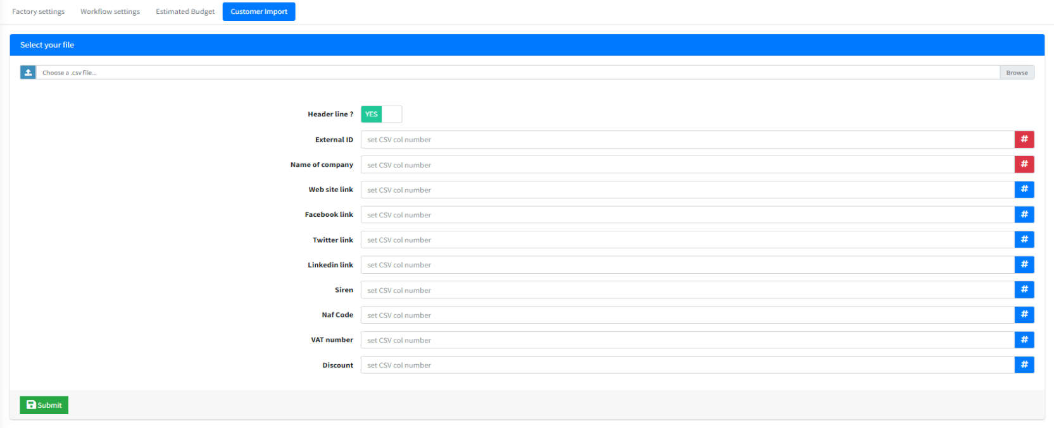
Companies csv import

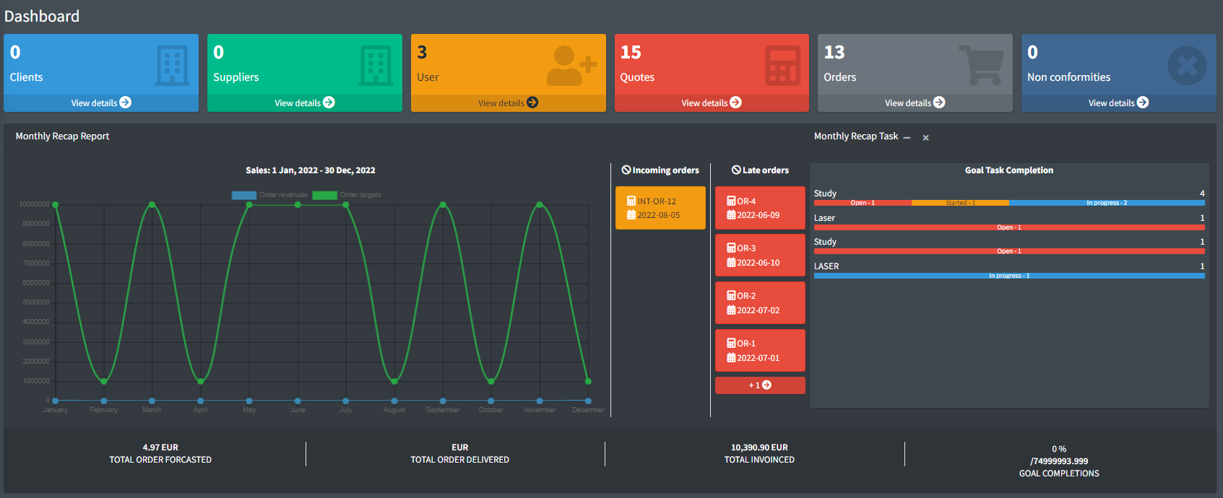
Dark Mode

Generic Task
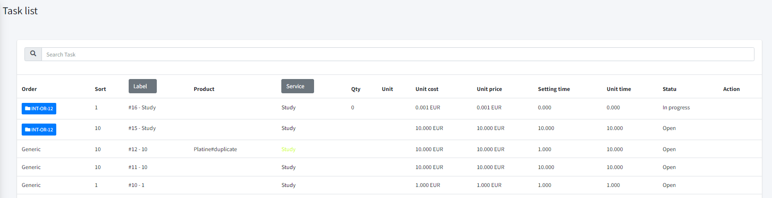

Logs activity

Order / Quotes / User / Task with spatie/laravel-activitylog

29 | default | created | App\Models\Planning\Task | created | 13 | App\Models\User | 1 | {"attributes": {"code": null, "products_id": null, "order_lines_id": null, "quote_lines_id": 1879}} |  | 2022-07-31 20:06:45 | 2022-07-31 20:06:45

Notifications
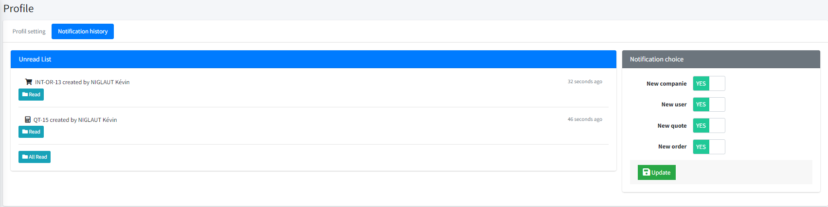
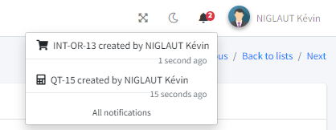

Calendar
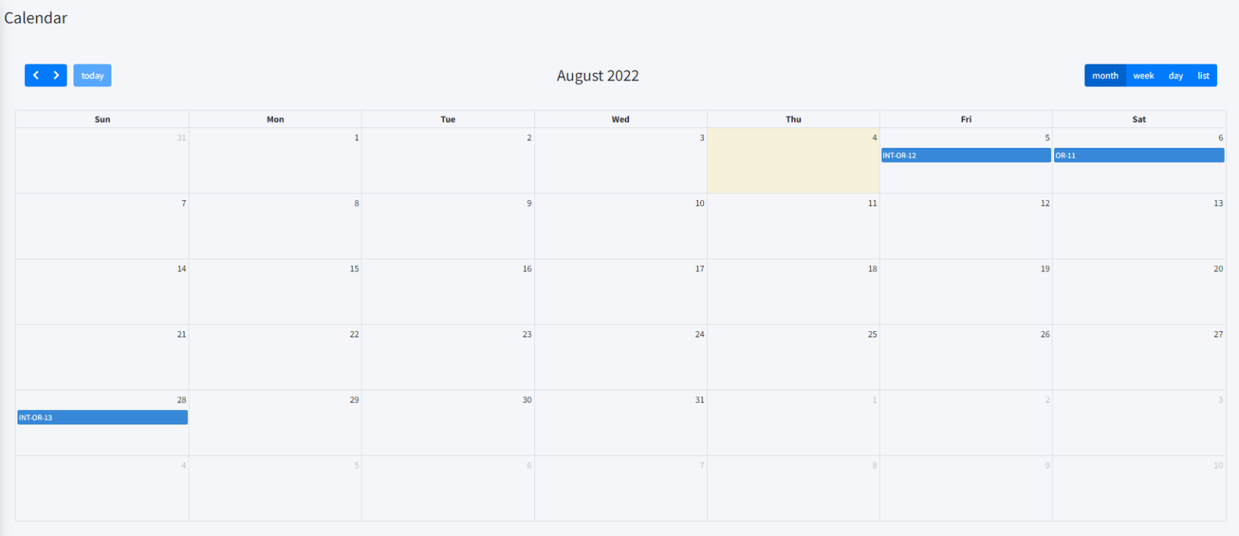

Document storage

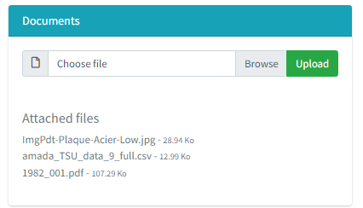

Fixe icons display on dashboard

Add call-out-info if we cant add line (quote/order)



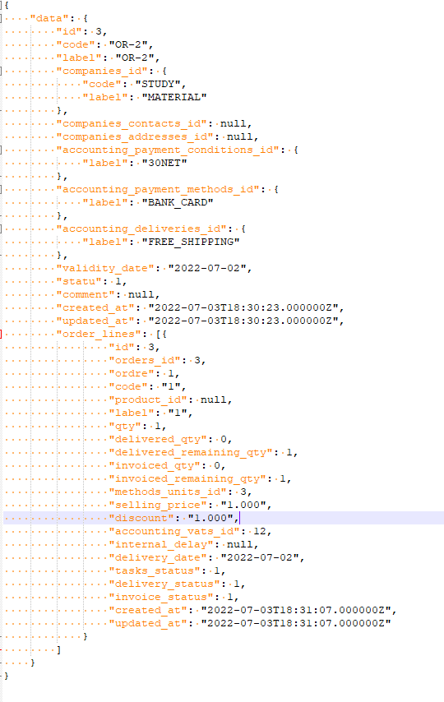
API for order data

Use blade Modal component

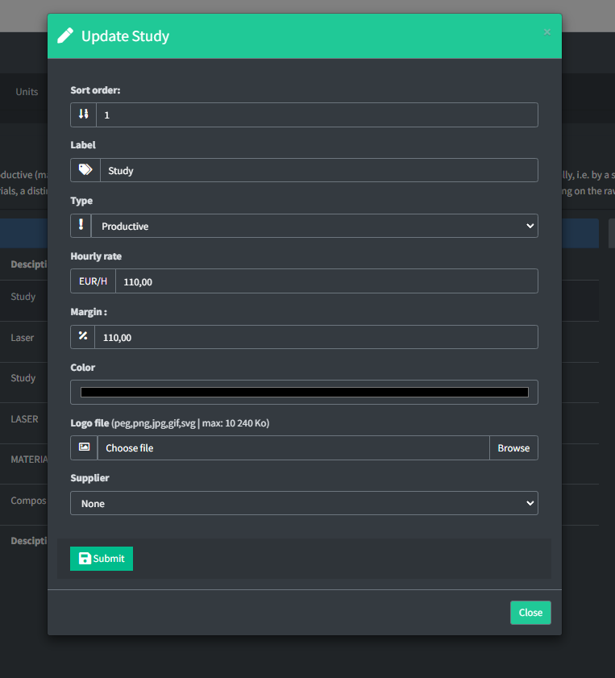

Break down the article task
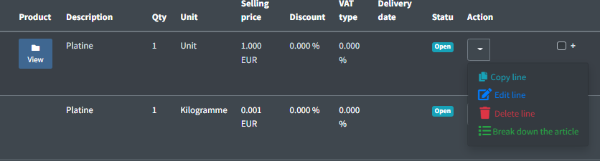

Autofil task label
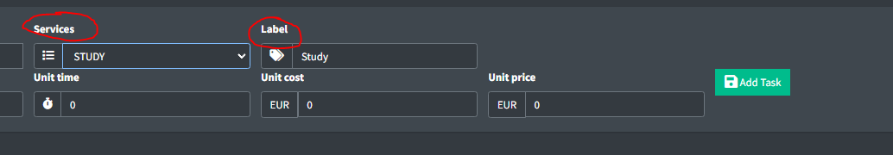

Internal order
